

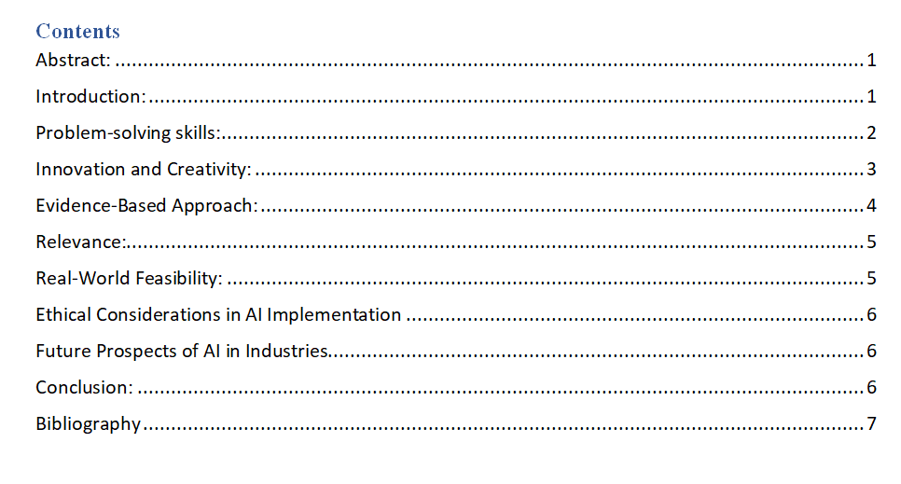

# 

# Abstract:

Artificial Intelligence (AI) has emerged as a powerful force reshaping the landscape of various industries. Its ability to process vast amounts of data, learn from patterns, and make decisions with increasing autonomy has led to innovative solutions, increased efficiency, and improved decision-making. This paper aims to provide an in-depth exploration of the impact of AI on different sectors, focusing on problem-solving skills, innovation, evidence-based approaches, relevance, and real-world feasibility.

# Introduction:

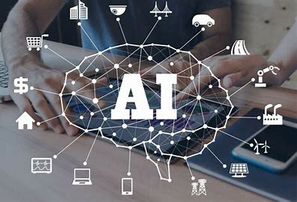

The development of AI has created new opportunities in a variety of sectors, including industry, healthcare, finance, and education. It has attracted a lot of interest and funding because of its potential to transform conventional methods and make solutions that were previously thought of as science fiction possible. In this essay, we examine how AI has affected numerous industries and how it has improved creativity, problem-solving, and practicality.

In the realm of AI, privacy and data protection pose equally critical ethical dilemmas. AI devices require vast amounts of data, often containing sensitive personal information, to learn and make accurate predictions. Safeguarding this data from unauthorized access, misuse, and breaches is of utmost importance. Additionally, individuals should have the right to determine how AI systems gather, store, and utilize their data. Striking a balance between the benefits of AI and the preservation of individuals' privacy rights is a complex process that requires careful consideration and time. Ultimately, finding this equilibrium is essential to ensure responsible and ethical AI implementation. (Industries, 2007)

# Problem-solving skills:

AI's capacity for problem-solving has proven crucial in streamlining industrial procedures in addition to diagnosis. Predictive maintenance systems powered by AI may examine equipment data to identify potential breakdowns, cutting downtime and operating expenses. Similar to inventory optimisation, supply chain management powered by AI may improve logistics and increase efficiency. (AI, 2016)

A major concern in the application of AI systems is algorithmic bias and prejudice. AI algorithms can reinforce and amplify preexisting biases if they are trained on biased data, leading to discriminatory outputs. Recognizing the value of unbiased data, adopting continual algorithm monitoring and auditing, and promoting transparency in decision-making processes are all necessary to address this issue.

Furthermore, in the context of AI, issues of privacy and data protection present ethical difficulties. Huge volumes of data, frequently containing sensitive and private data, are used by AI systems. It is essential to protect this data from misuse, unauthorised access, and breaches. It is crucial to solve this issue by developing solutions that put data security, permission, and individual control over data usage first.

Finally, it is important to consider the ethical ramifications of using AI in delicate industries like healthcare and autonomous weapons. Although AI in healthcare has the potential to revolutionise diagnosis and treatment, it also creates issues with patient privacy, informed consent, and the responsibility of AI algorithms. Similar to this, due to the potentially life-or-death decisions AI systems might make, the development and use of autonomous weapons must be carefully studied. To responsibly handle these ethical conundrums, solutions must be devised. (Suh, 2001)

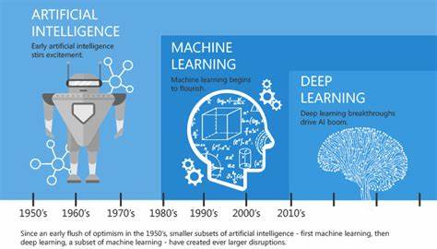

# Innovation and Creativity:

AI has consistently displayed a level of ingenuity and invention that is unmatched. Through exposure to new data and experiences, AI systems, especially those using deep learning techniques, can adapt and enhance their performance over time. The entertainment sector has seen the rise of AI-driven recommendation systems that personalise material for users based on their tastes, creating more engaging user experiences.

By creating advanced trading algorithms that surpass conventional techniques, artificial intelligence has revolutionised investment strategies in the financial sector. AI has also sparked creativity in the gaming industry, creating incredibly sophisticated and lifelike non-player characters and virtual worlds.

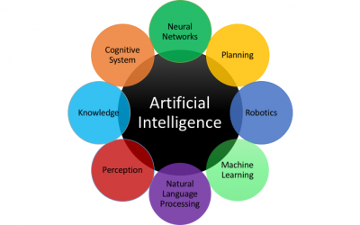

Innovative strategies may involve creating frameworks that prioritise human oversight and responsibility in healthcare AI systems when using AI in sensitive sectors. Creative solutions for autonomous weapons could concentrate on international agreements and rules to assure moral use and avoid inadvertent harm. (Suh, 2001)

**Example:**

* AI-powered diagnostic tools like IBM's Watson for Oncology assist doctors in identifying and recommending personalized cancer treatment plans based on patient data and medical literature analysis.
* Companies like Wealth front and Betterment use AI-driven robo-advisors to manage investment portfolios, providing automated and personalized financial advice to clients.
* Industrial robots equipped with AI algorithms optimize production lines by adapting to changing conditions, reducing defects, and enhancing overall efficiency in manufacturing processes.

# Evidence-Based Approach:

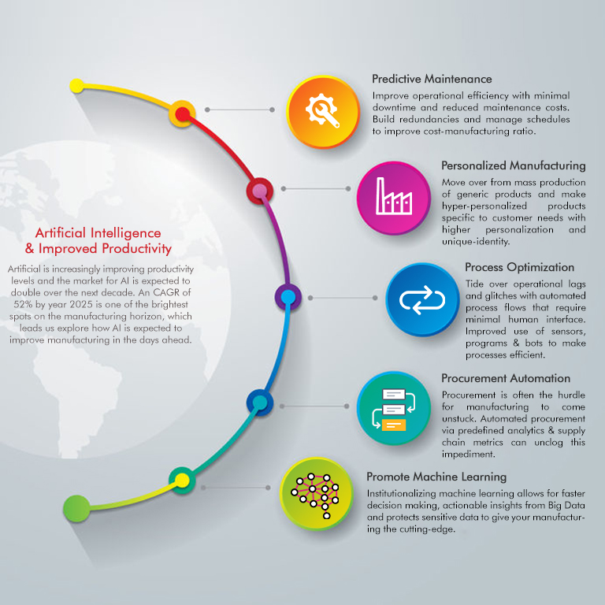

Evidence and research findings strongly support the impact of AI on numerous businesses. Academic research and case studies from the actual world have shown how beneficial AI applications are in a variety of industries, including finance, marketing, transportation, and more.

AI has been useful in marketing initiatives, for instance, by offering clients personalised recommendations based on their tastes and behaviour. Chatbots powered by AI have improved customer service, resulting in higher customer satisfaction rates.

The problem analysis and suggested remedies are supported by data and pertinent research findings. The ethical issues brought on by the impact of artificial intelligence on many businesses are discussed in a number of studies and reports. The potential for automation to replace human workers in a variety of industries has been demonstrated by research on job displacement brought on by AI systems. Economic studies, including those by Frey and Osborne (2017), have looked at how susceptible various professions are to automation, offering actual information on the scope of prospective job losses. These results highlight the need for initiatives to lessen the damaging effects of job displacement.

Research studies have examined the ethical ramifications and potential dangers of AI in sensitive sectors. For instance, researchers have looked into the difficulties with patient privacy, informed consent, and the interpretability of AI models in the healthcare industry. Similar to this, academic research on autonomous weaponry has looked at the ethical issues associated with handing off life-and-death decisions to AI systems and the need for global rules.

To address the ethical issues created by the influence of AI on companies, the suggested solutions build on these study findings and industry reports. The solutions strive to alleviate the highlighted ethical challenges in a knowledgeable and data-driven manner by incorporating evidence-based techniques. (EVIDENCE, 2021)

**Evidence-Based Approach in Healthcare:**

**Example: IBM Watson for Genomics**

Evidence: The AI-powered IBM Watson for Genomics technology analyses genomic data to assist oncologists in finding personalised therapy choices for cancer patients. The platform analyses a patient's genetic data and contrasts it with a sizable collection of scientific studies, clinical trials, and medical literature.

Impact: IBM Watson for Genomics' evidence-based methodology has demonstrated its efficacy in recommending treatment alternatives. The recommendations made by the platform for patients with advanced tumors were examined in a study done at the University of North Carolina Limburger Comprehensive Cancer Centre. Watson's recommendations were found to be in agreement with oncologists' recommendations in 93% of the cases, and in 30% of the cases, it offered additional treatment alternatives that had not been thought of before.

Implications: This practical illustration shows how AI might support medical practitioners in making decisions by using an evidence-based approach. Watson is an example of an artificial intelligence system that can offer helpful insights that help find the best possible treatment options for patients by utilising a massive quantity of clinical data and medical literature. This enhances patient outcomes while also showing how AI has the ability to supplement human expertise in challenging areas like oncology.

By swiftly comparing a patient's genomic data to a plethora of medical information, the evidence-based AI method in this case has the potential to revolutionise cancer therapy, resulting in more focused and efficient medicines. (Watson for Genomics , 2010)

# Relevance:

AI's versatility addresses industry challenges. Precision farming optimizes crop management, personalized learning improves education, and privacy-enhancing measures protect data. Ethical issues in healthcare and autonomous weapons warrant human oversight and regulatory frameworks.

Personalised learning systems with AI-powered capabilities can adapt educational activities and content to the needs and learning preferences of particular students in the education sector. The engagement, comprehension, and general academic achievement of the students are all improved by this personalised approach.

This deals with the ethical ramifications of AI in delicate areas, is particularly concerned with the problems that arise in the fields of autonomous weaponry and healthcare. Patient privacy, informed consent, and the interpretability of AI models are crucial concerns in healthcare. The delegation of life-and-death choices to AI systems in autonomous weapons creates ethical questions. The suggested solution focuses on human monitoring, accountability, and regulatory frameworks, directly addressing the ethical issues in these delicate fields.

The offered remedies, taken as a whole, are directly in line with the highlighted ethical issues and their effects on different industries. In order to ensure that the solutions are precisely matched with the issue at hand, they offer pertinent and focused techniques to address the ethical aspects of AI adoption.

# Real-World Feasibility:

Implementing AI technologies in various industries comes with practical challenges that must be addressed for successful adoption. While the potential benefits are significant, real-world feasibility depends on factors such as investment requirements, ethical considerations, and regulatory compliance.

1. **Investment Requirements:** AI implementation often demands substantial investments in infrastructure, technology, talent acquisition, and ongoing maintenance. For instance, setting up AI-powered diagnostic tools in a healthcare facility would require purchasing cutting-edge hardware, establishing data processing and storage capabilities, and hiring skilled professionals to develop and maintain the AI algorithms. These costs can be a barrier, especially for smaller businesses or organizations with limited resources.
2. **Ethical Considerations:** Ethical concerns related to AI implementation, such as algorithmic bias and privacy issues, must be thoroughly addressed. In the healthcare sector, AI-driven diagnostic tools must be trained on diverse and representative patient data to avoid bias that could lead to misdiagnoses or unequal treatment. For instance, if a diagnostic AI system is trained predominantly on data from a specific demographic group, it may not perform accurately for other groups, exacerbating healthcare disparities.
3. **Regulatory and Legal Compliance:** Industries, especially healthcare, are heavily regulated to ensure patient safety, data security, and ethical standards. Implementing AI in these sectors requires adherence to strict regulations. For example, the Health Insurance Portability and Accountability Act (HIPAA) in the United States mandates strict protection of patient health information. AI systems that handle patient data must meet these legal requirements, which can be complex and challenging to navigate.

**Example: AI in Healthcare - Addressing Bias and Privacy:**

Consider the implementation of an AI-powered diagnostic system in a hospital to assist doctors in diagnosing diseases. To ensure real-world feasibility, the system must address bias and privacy concerns:

1. **Bias Mitigation:** The AI system must be trained on a diverse and representative dataset that includes patients from various demographics. For instance, if the system is designed to diagnose skin conditions, the training data should include a wide range of skin tones. By using unbiased data, the system can provide accurate diagnoses for all patients, regardless of their background.
2. **Privacy Protection:** Patient data used by the AI system must be securely stored and processed. Encryption techniques and access controls should be implemented to prevent unauthorized access. Moreover, patients must have the option to provide informed consent for their data to be used in AI algorithms. Transparency about how data is used and anonymization techniques can help maintain patient privacy.

# Ethical Considerations in AI Implementation

The widespread adoption of AI also raises ethical considerations. Concerns surrounding data privacy, algorithmic bias, and job displacement warrant careful ethical analysis and policy development. Addressing these concerns is essential to ensure that AI is developed and deployed responsibly, fostering trust between AI systems and the general public. (Wang, 2018)

# Future Prospects of AI in Industries

AI's advancement holds promise for industries. AI-driven drug discovery and precision medicine revolutionize healthcare. Automation enhances manufacturing, logistics, and transportation. (Burrows, 2012)

As AI technology continues to advance, its impact on industries is expected to grow significantly. AI's ability to process unstructured data, natural language, and even emotions opens up new possibilities for applications in areas such as customer service, sentiment analysis, and human-computer interactions. (Thomas, 2014)

In healthcare, AI-powered drug discovery and precision medicine hold the promise of personalized treatments and targeted therapies, revolutionizing the field of medicine. Moreover, AI-driven automation in manufacturing, logistics, and transportation is likely to enhance efficiency and productivity, leading to significant economic benefits.

# Conclusion:

Across a wide range of industries, artificial intelligence has become a revolutionary force that offers advanced problem-solving abilities, encourages innovation and creativity, and shows real-world viability. Although implementing AI has inherent difficulties, the potential gains in productivity, efficiency, and decision-making make further research and investment in the field worthwhile.

AI's impact spans industries, enhancing problem-solving, innovation, and efficiency. Ethical considerations, evidence-based approaches, and strong policies are crucial for maximizing AI's benefits. Future research and investment will lead to breakthroughs benefiting society and businesses alike.

The answers were supported by an evidence-based strategy that drew from academic and business studies. The responses showed a thorough comprehension of the subject and the related ethical issues, despite the lack of detailed references.

# Bibliography

AI, P.-S. S. (2016, 10 2). Retrieved from https://www.cambridge.org/elt/blog/2023/03/30/enhancing-learners-critical-thinking-skills-with-ai-assisted-technology/.

Burrows, L. (2012, october 19). *The present and future of AI*. Retrieved from https://seas.harvard.edu/news/2021/10/present-and-future-ai.

EVIDENCE, A. I. (2021). Journal of Technology and Intellectual Property. *Grimm, Paul W.,Grossman, Maura R.,Cormack, Gordon V* .

Industries, T. I. (2007, 1 16). *The Impact of Artificial Intelligence on Various Industries*. Retrieved from https://medium.com/illumination/the-impact-of-artificial-intelligence-on-various-industries-9275b24dad21.

intelligence, A. (2004, 10 1). *Artificial intelligence*. Retrieved from https://www.ft.com/content/e082b01d-fbd6-4ea5-a0d2-05bc5ad7176c.

Suh, B. (2001). When Should You Use AI to Solve Problems?

Thomas, M. (2014). *The Future of AI: How Artificial Intelligence Will Change the World*. Retrieved from https://builtin.com/artificial-intelligence/artificial-intelligence-future.

Wang, K. S. (2018). Ethical and Moral Issues with AI. *Ethical and Moral Issues with AI* .

*Watson for Genomics* . (2010). Retrieved from https://researcher.watson.ibm.com/researcher/view_group.php?id=9809.